Project Title : Design Sell( Sample Website)
Date 06/04/2022 Prepared By : K.Gopi Kalyan
Project Justification:
This project is basically about the dog’s daycare. It is about to take about the dogs by providing the healthy diet, adoptions, health tips, weight loss for dogs etc. It has home page, about us and contact page.
Product Characteristics and Requirements :
1. Home page
2. User tracking
3. Search feature
4. Contact details
5. Registration form
Project Success Criteria: Our main goal is to complete this project to provide a quality dog daycare program will offer healthy activity and stimulation for your pup, which helps alleviate negative behaviors. Combined with the mental stimulation that dog daycare provides your energetic pup, it also provides essential exercise to keep him/her in top physical condition. It shares many similarities with a regular daycare for children, with the exception being that a dog daycare is for canines.

Webpages

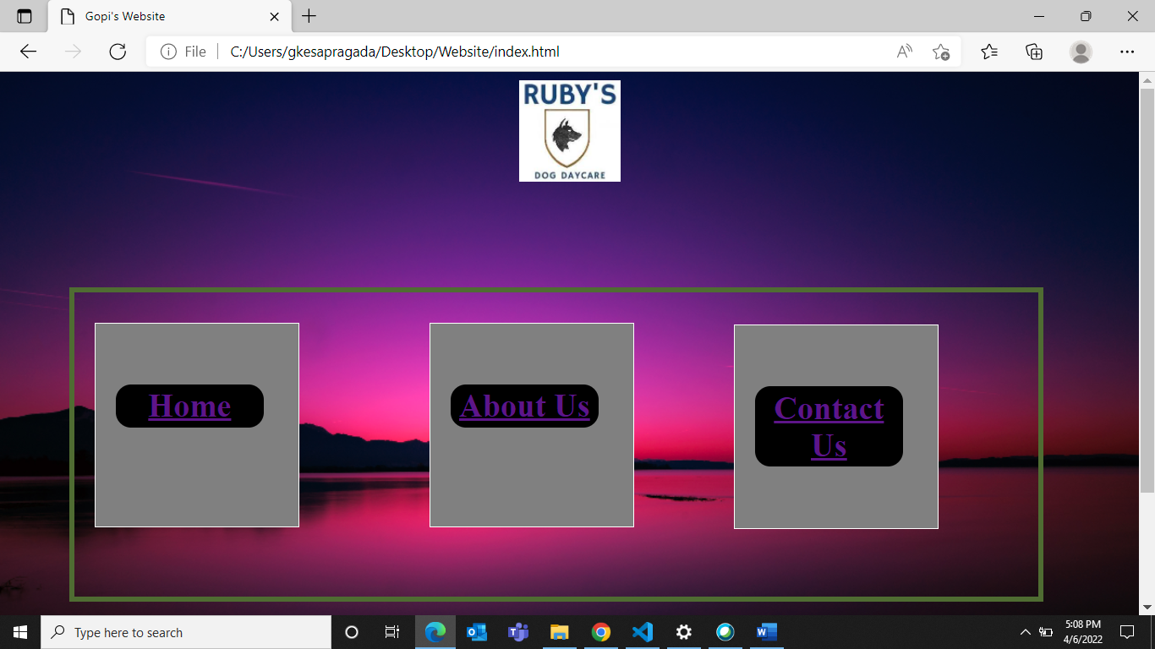

Description: It consists of logo, home, aboutus, and contactus in index page where I provided links to each by using anchor tags. This direct us into the new page separately.
An anchor tag is a HTML element that creates a link to a target URL. When correctly implemented, the link can wrap around text, images, or as buttons

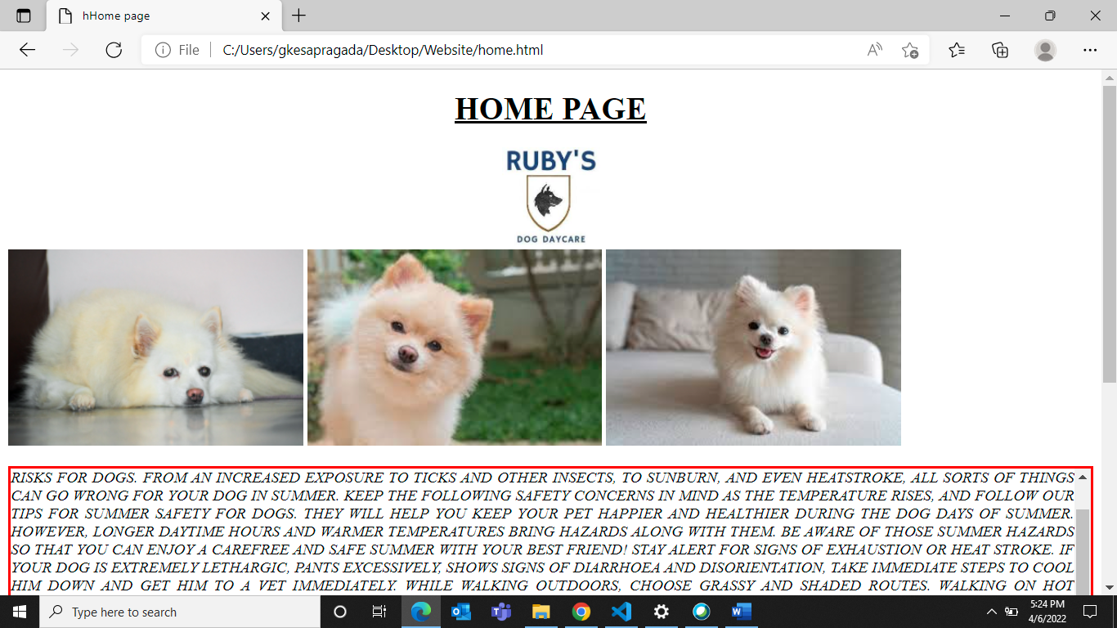

Description: This is the breif intro about the dog’s day care. Summer healthy tips, weight again and loss.
The text-transform property controls the capitalization of text.
The overflow property specifies whether to clip the content or to add scrollbars when the content of an element is too big to fit in the specified area.
The overflow property specifies what should happen if content overflows an element's box. This property specifies whether to clip content or to add scrollbars.
The float CSS property places an element on the left or right side of its container, allowing text and inline elements to wrap around it.

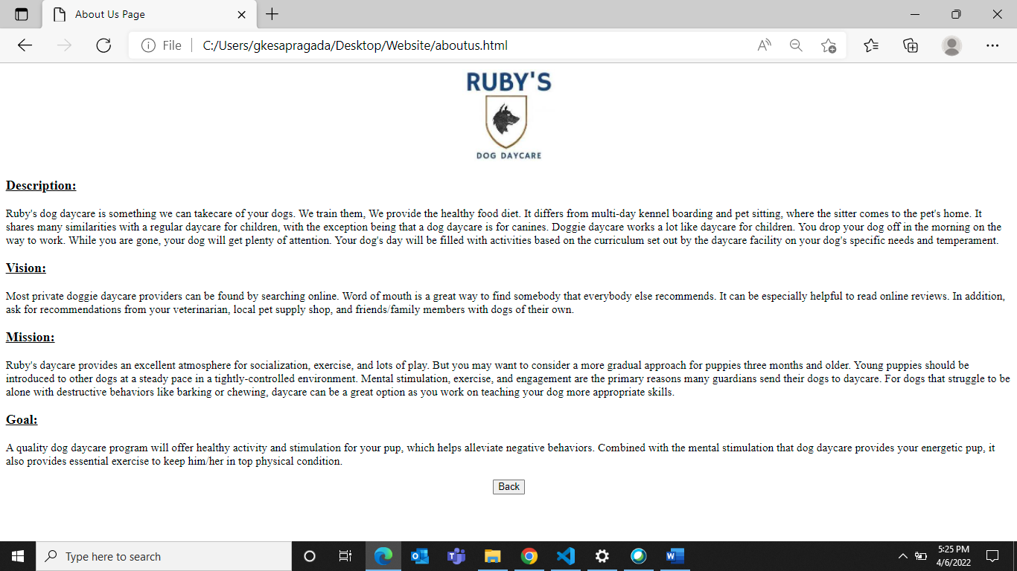

Description: It is just about a simple description about the project and its future scope.

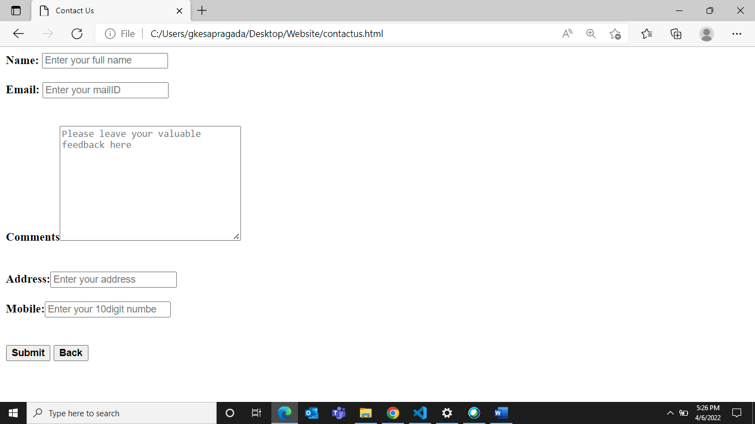

Description: It is contact us form where you can give mobile number and email address for registration. Clean and minimal HTML/CSS contact form with minimal styling to be used on websites. Use a <form> element to process the input.
First we create the HTML elements input fields for First Name, Last Name, Email and a Text Area for the message. Later we apply CSS styles.

